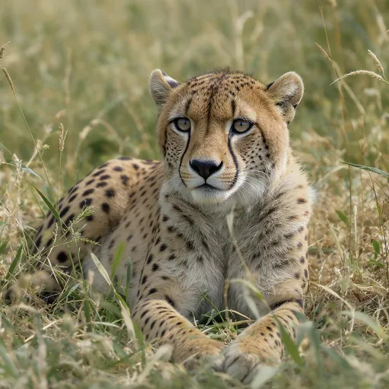"A cheetah lying in the grass, blending in with the landscape, ready to pounce on its prey."

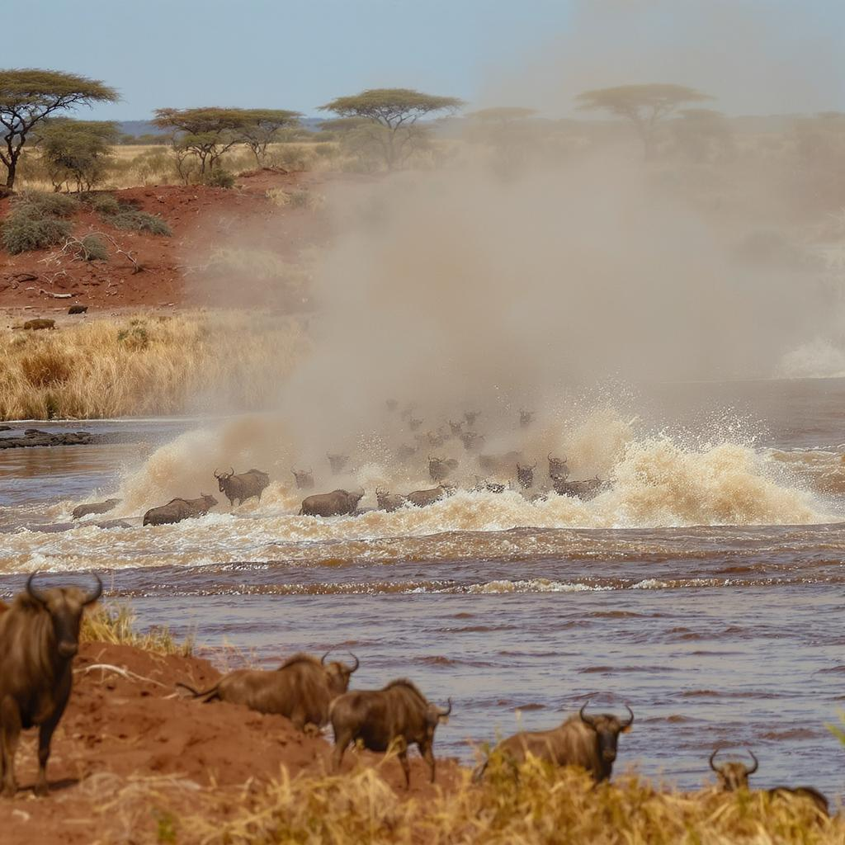"A herd of wildebeests crossing a river during their great migration in Africa."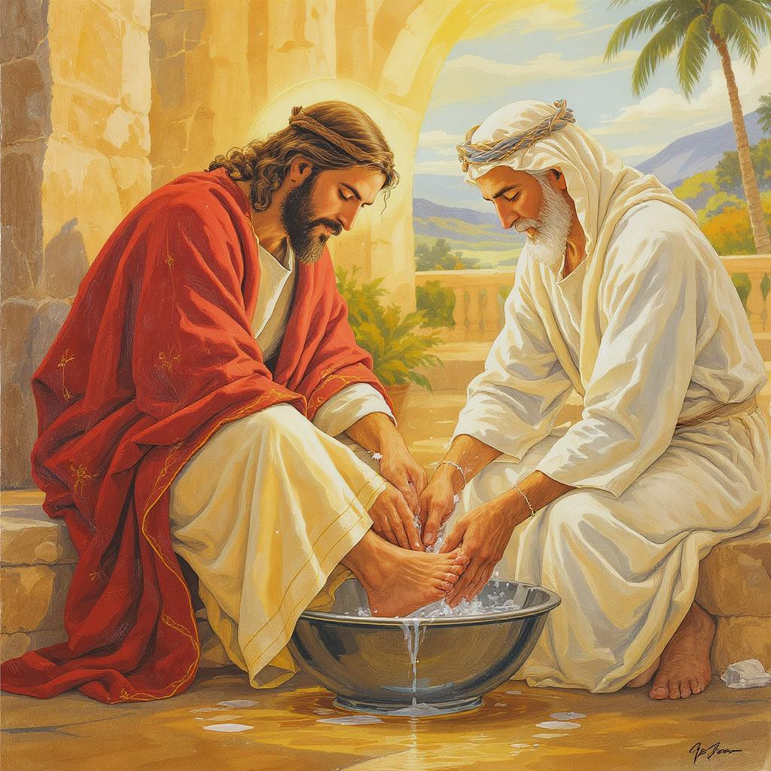

Reflection 1. And 2. I would ask AI to be more specific,The funnest thing about this is tok see what type of images AI would create